Azure Databricks Lessons 1 and 2
Simple student notes with examples and practice questions
Audience Beginners who know basic programming, SQL or Java
Scope From first workspace navigation to a governed Delta table
Environment One Premium Azure Databricks workspace • 14 learners • one learner schema each

How to use this document
These notes explain every new term before using it. Read the plain-language explanation, study the small example, and then answer the check question. The examples use a retail company so that the business purpose remains visible while you learn the technology.
Lesson | Main idea | Practical result
1 What Azure Databricks is | How storage, Spark, Delta Lake and Unity Catalog work together | A Spark DataFrame with a calculated total
2 Workspace, notebooks and compute | Where work is organized and what actually executes code | A notebook that runs Python, SQL and Markdown
Combined practice | Persist the temporary DataFrame as a governed table | training_lab.student_01.orders

CLASS CONVENTION: Replace student_01 with the schema assigned to you. Never use another learner’s schema.

Lesson 1 What is Azure Databricks

Learning outcomes
- Explain Azure Databricks in simple words.
- Describe why companies need a distributed data platform.
- Identify the roles of ADLS, Apache Spark, Delta Lake and Unity Catalog.
- Create a small Spark DataFrame and calculate a new column.
- Explain the three-level name catalog.schema.table.

1.1 Simple definition
Azure Databricks is a cloud platform for processing, analyzing and governing data. Engineers can build data pipelines, analysts can run SQL, and data scientists can train models while using the same governed data.
In very simple words, Databricks is a modern data-processing factory. Data enters in a raw form, workers clean and transform it, quality checks make it trustworthy, and the finished data becomes available for reports, applications or machine learning.
Databricks can help us | Simple example
Read large amounts of data | Load millions of order records from cloud storage
Clean and transform data | Remove invalid quantities and calculate order totals
Build pipelines | Run the same processing every morning
Run SQL analytics | Find sales by product and month
Process streaming data | Analyze events arriving continuously
Build machine-learning models | Predict customer demand
Secure and govern data | Allow each learner to use only an assigned schema

1.2 Why companies need Databricks
Imagine a retail company. It receives information from online orders, physical stores, mobile applications, customer systems, payment services, IoT devices and files such as CSV or JSON. These sources do not automatically agree with one another.
Raw-data problem | Retail example | What processing must do
Missing values | An order has no customer ID | Validate the field and apply a business rule
Duplicates | The same payment event arrives twice | Identify the business key and remove or merge duplicates
Incorrect values | Quantity is negative | Reject, quarantine or correct the record
Different formats | One date is text and another is a timestamp | Convert to a consistent type
Large volume | Billions of transactions | Divide the work across compute resources

Before management can see a reliable sales dashboard, the data must be collected, cleaned, validated, combined, summarized, secured and published. Databricks supplies a common platform for these activities.

Check your understanding
Question: Why can a dashboard not safely read every raw file directly?
Answer: Raw files can contain missing values, duplicates, inconsistent types and unverified business rules. A trusted dashboard needs processed and governed data.

1.3 Factory analogy
Use this analogy only to learn the responsibilities. Afterward, use the exact technical names.
Technology | Factory analogy | Real responsibility
Azure | The city and utilities | Provides cloud infrastructure
ADLS Gen2 | Warehouse | Stores raw and processed files
Databricks workspace | Factory campus | Organizes notebooks, jobs, queries and collaboration
Apache Spark | Workers and machinery | Processes data in parallel
Delta Lake | Inventory ledger | Records reliable table changes
Unity Catalog | Security gate and register | Names assets and controls access
Lakeflow Jobs | Factory schedule | Runs repeatable work at planned times
SQL warehouse | Reporting department | Executes analytical SQL and BI queries

A useful sentence to remember is: ADLS stores the data, Spark processes the data, Delta Lake makes tables reliable, Unity Catalog governs access, and Databricks brings the experience together.
JAVA CONNECTION: A notebook resembles source code plus an interactive console. Compute is the runtime. Spark is the execution engine. Unity Catalog is the governed namespace and authorization layer.

1.4 Where the data is stored
Business data normally lives in cloud storage such as Azure Data Lake Storage. Databricks reads that data, processes it and writes trusted output. A Delta table is backed by data files plus a transaction log that records committed changes.
Stage | Example | Purpose
Source systems | Website, store and payment platform | Produce business events
Cloud storage | ADLS folders and files | Hold raw and processed data
Azure Databricks | Notebook and Spark compute | Clean, transform and validate
Delta table | training_lab.student_01.orders | Provide a reliable governed table
Consumer | Power BI, SQL, application or ML | Use the trusted result

The workspace also stores platform information such as notebooks, job definitions, permissions, compute configurations, query metadata and experiment information. Do not confuse this workspace information with the business data files.

The lakehouse idea
A data lake gives economical cloud storage and open file formats. A data warehouse gives managed tables and reliable SQL behavior. A lakehouse adds table-management and governance capabilities to data held in lake storage.

1.5 The main technical layers
Layer | What it does | Beginner question
Workspace and control services | Provide the user interface, notebook metadata and service management | Where do I organize my work?
Compute | Runs Python, Spark and notebook SQL commands | What machine performs the work?
Cloud storage | Holds source files and table data | Where do the bytes live?
Unity Catalog | Provides governed names, permissions and discovery | Who can use which object?

Spark in one paragraph
Apache Spark divides large work into tasks. A driver coordinates the application and creates an execution plan. Executor processes work on partitions, which are slices of the data. This is valuable when the dataset is too large or the processing is too expensive for one machine.
Spark term | Simple meaning | Java analogy
Driver | Coordinator that builds the plan and schedules tasks | The main coordinating process
Executor | Worker process that performs tasks | A process in a worker pool
Partition | A slice of the distributed data | A chunk assigned to one worker
Transformation | Description of a new DataFrame | An intermediate Stream operation
Action | Request for a result or write | A terminal Stream operation

1.6 Simple retail example
The business requirement is to calculate total_amount for each order.
order_id | product | quantity | unit_price
O101 | Laptop | 1 | 60000.0
O102 | Mouse | 2 | 800.0
O103 | Keyboard | 3 | 1500.0

PYTHON
from pyspark.sql import functions as F
orders = [
('O101', 'Laptop', 1, 60000.0),
('O102', 'Mouse', 2, 800.0),
('O103', 'Keyboard', 3, 1500.0)
]
columns = ['order_id', 'product', 'quantity', 'unit_price']
orders_df = spark.createDataFrame(orders, columns)
result_df = orders_df.withColumn(
'total_amount',
F.col('quantity') * F.col('unit_price')
)
display(result_df)
order_id | product | quantity | unit_price | total_amount
O101 | Laptop | 1 | 60000.0 | 60000.0
O102 | Mouse | 2 | 800.0 | 1600.0
O103 | Keyboard | 3 | 1500.0 | 4500.0

1.7 Code explanation line by line

Import Spark functions
PYTHON
from pyspark.sql import functions as F
This imports reusable Spark functions. F is a short alias. F.col("quantity") refers to the quantity column inside a DataFrame expression.

Create the Python data
PYTHON
orders = [('O101', 'Laptop', 1, 60000.0)]
This is ordinary Python data used for a small demonstration. A real application would normally read files, tables, streams or databases.

Create the Spark DataFrame
PYTHON
orders_df = spark.createDataFrame(orders, columns)
A DataFrame is a distributed table with rows, named columns and a schema. It looks like an Excel or database table, but Spark can process its partitions across multiple machines.

Add the calculated column
PYTHON
result_df = orders_df.withColumn(
'total_amount',
F.col('quantity') * F.col('unit_price')
)
withColumn creates or replaces a column and returns a new DataFrame. The calculation is total_amount = quantity × unit_price. The original orders_df remains available.

Display the result
PYTHON
display(result_df)
display requests a result, so Spark plans and executes the required work. Databricks shows the result in an interactive table and may offer chart options.

1.8 Lazy evaluation
Spark usually waits before processing the full dataset. Transformations such as filter, select and withColumn build a logical plan. An action such as display, count or write asks Spark to produce a result. Waiting lets Spark optimize the complete plan.
Operation | Type | Why
filter | Transformation | Defines which rows the new DataFrame should contain
select | Transformation | Defines which columns should remain
withColumn | Transformation | Defines a new or replaced column
display | Action | Requests rows for the notebook result
count | Action | Requests a number
write | Action | Requests output to storage or a table

IMPORTANT: collect is also an action, but it brings all returned rows to the driver. Avoid it for large data.

Check your understanding
Question: Which line in the retail example most clearly requests Spark to return data to the notebook?
Answer: display(result_df).

1.9 Save the result as a Delta table
PYTHON
result_df.write \
.format('delta') \
.mode('overwrite') \
.saveAsTable('training_lab.student_01.orders')
This creates or replaces a governed Delta table named training_lab.student_01.orders. Use overwrite only for this isolated rerunnable lab. In production, confirm ownership, expected row counts and recovery rules before replacing data.
Name level | Example | Meaning
Catalog | training_lab | Main governed domain for the class
Schema | student_01 | The learner’s assigned area
Table | orders | The actual governed dataset

SQL
SELECT *
FROM training_lab.student_01.orders
ORDER BY total_amount DESC;

What happens internally
1. The notebook sends commands to connected compute.
2. Spark builds and optimizes an execution plan.
3. Spark divides the work into tasks and processes partitions.
4. The writer stores Delta data and commits a transaction-log entry.
5. Unity Catalog checks the learner’s privileges and registers the table name.
6. Authorized SQL, dashboards, jobs and pipelines can find the table.

Lesson 1 summary
Question | Short answer
Where is business data normally stored? | Cloud storage such as ADLS
Which engine processes distributed data? | Apache Spark
What makes Delta tables reliable? | Parquet data plus a transaction log and table rules
What controls governed access? | Unity Catalog
What does catalog.schema.table represent? | A fully qualified governed table name
Why does Spark use lazy evaluation? | To optimize the complete plan before an action requests work

Explain the lesson in one sentence: Databricks uses compute and Spark to process data stored in cloud storage, Delta Lake to make tables reliable, and Unity Catalog to name and govern those tables.

Lesson 2 Workspace, notebooks and compute

Learning outcomes
- Explain the difference between the Azure portal and a Databricks workspace.
- Identify the main areas of the workspace.
- Create and name a notebook.
- Use Python, SQL and Markdown cells.
- Explain why a notebook needs compute.
- Compare serverless, classic, jobs and SQL compute.

2.1 What a workspace is
A Databricks workspace is the main collaborative environment where users organize data and AI work. It contains notebooks, folders, queries, dashboards, job definitions, compute choices, machine-learning assets and links to Unity Catalog objects.
Think of the workspace as an office building. It contains rooms and working materials, but it does not execute PySpark code by itself. Compute executes the code.
Databricks component | Office analogy
Workspace | Office building
Notebook | Employee working document
Compute | Computer or processing machine
Workspace folder | File cabinet
Unity Catalog | Security and access-control department
Lakeflow Job | Automated work schedule
SQL warehouse | Reporting department

2.2 Azure portal versus Databricks workspace
Azure portal | Databricks workspace
Creates and manages Azure resources | Performs data engineering, SQL, analytics and AI work
Manages subscriptions and resource groups | Contains notebooks, jobs, queries and dashboards
Configures Azure networking and identities | Processes data and applies object permissions
Controls Azure role-based access | Controls Databricks workspace and Unity Catalog access
Used mainly by cloud administrators | Used by engineers, analysts and data scientists

A trainer sentence to remember is: We use the Azure portal to create and manage the Azure Databricks service. We enter the Databricks workspace to create notebooks, process data, run SQL and build pipelines.

2.3 Important workspace areas
Area | What you use it for
Workspace | Browse notebooks, files and folders
Catalog | Browse catalogs, schemas, tables, volumes, functions and models
Compute | View or select approved serverless and classic compute
SQL | Use the SQL editor, warehouses, queries, dashboards and alerts
Jobs and Pipelines | Build repeatable, scheduled workflows

2.4 What a notebook is
A notebook is an interactive document containing executable code, SQL queries, Markdown explanations and results. It combines features of a Java IDE editor, a SQL editor, a technical document and an execution console.
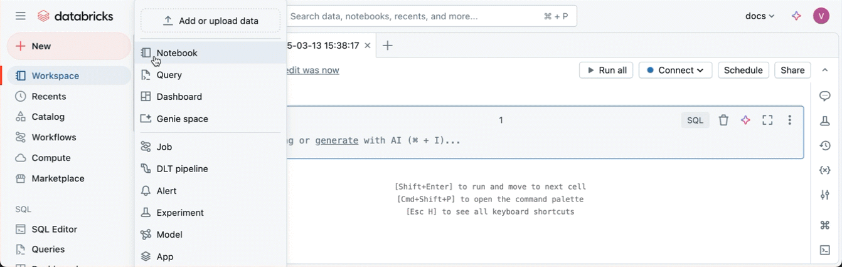
Recent workspace New menu. Select Notebook to create a blank notebook.
In the current interface, + New → Notebook creates a blank notebook. It may first appear in Drafts. After you give it a name, it moves to your home workspace folder. In an eligible Unity Catalog workspace, the notebook may connect to serverless compute automatically.

Notebook cell types
Cell type | Example | Purpose
Python | print("Hello Azure Databricks") | Run Python or PySpark code
SQL | %sql SELECT current_user(); | Run a SQL statement
Markdown | %md # Student Marks Analysis | Document the purpose and steps
Scala | %scala println("Hello") | Run Scala where needed

2.5 Default language and magic commands
The notebook default language controls cells that do not start with a language magic command. Select Python for this course because the labs use PySpark. A Python notebook can still contain SQL and Markdown cells.
SQL CELL
%sql
SELECT current_date() AS today;
MARKDOWN CELL
%md
## Order Processing Lab
This section calculates the total order amount.
The command must appear at the start of the cell. Keep one purpose per cell so that setup, transformations, validation and publishing can be rerun safely.
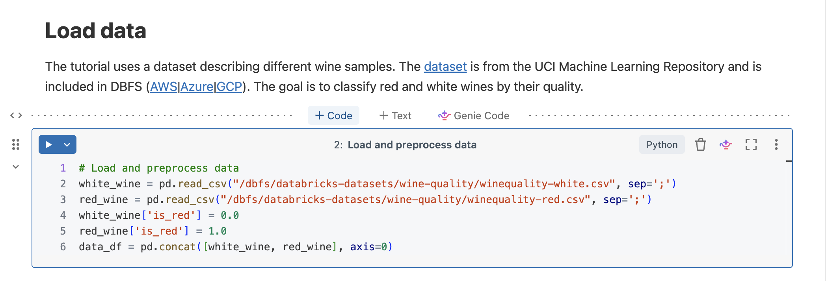
Recent notebook cell controls. Hover between cells or use the cell menu to add another cell.

Good notebook structure
- Title and objective in Markdown.
- Imports and configuration.
- Source data creation or reading.
- Transformations.
- Validation and expected results.
- Publishing to a governed table.

2.6 What compute is
Compute is the processing resource that executes notebook commands. Without compute, Python code cannot run, Spark DataFrames cannot be processed, notebook SQL cannot execute, and data cannot be read or written.
Item | Factory meaning
Notebook | Instructions
Compute | Worker or machine
Data | Raw material
Result | Finished product

Recent notebook toolbar and compute selector. Labels can vary by workspace capability.

Main compute choices
Compute type | Best use | Key point
Serverless | Supported interactive notebooks, jobs and pipelines | Databricks manages infrastructure and startup
Classic all-purpose | Interactive work that needs explicit runtime or node configuration | Use a policy and auto termination
Jobs compute | Scheduled and repeatable production tasks | Created for automated runs, not day-long exploration
SQL warehouse | SQL editor, dashboards, alerts and BI tools | Separate from notebook Spark compute

2.7 Classroom setup for 14 learners
A practical class does not need 14 Azure Databricks workspaces. Use one Premium workspace, one Microsoft Entra learner group, approved compute, one shared SQL warehouse if required, and one schema per learner.
Component | Classroom design | Reason
Workspace | One Premium workspace | Lower administration and consistent demonstrations
Identity | One Entra learner group | Manage access as a group
Compute | Serverless where supported, otherwise governed shared compute | Faster start or controlled configuration
SQL | One shared SQL warehouse | Enough for guided SQL exercises
Data isolation | student_01 through student_14 schemas | Each learner publishes to an assigned area
Cost control | Serverless policies or auto termination | Reduce idle usage

SECURITY: Learners need permission to use approved compute and their assigned schema. They do not need unrestricted compute creation or workspace administrator rights.

2.8 First notebook example
PYTHON
print('Hello Azure Databricks!')
print('Spark version:', spark.version)
spark is the Spark session that Databricks provides to the notebook. A local PySpark application might create a SparkSession explicitly, but a Databricks notebook prepares it for you.
PYTHON
students = [
(1, 'Asha', 85),
(2, 'Ravi', 72),
(3, 'Meena', 91),
(4, 'Imran', 68)
]
columns = ['student_id', 'student_name', 'marks']
students_df = spark.createDataFrame(students, columns)
display(students_df)
spark.createDataFrame converts normal Python data into a Spark DataFrame. display shows the result in the notebook.
PYTHON
passed_df = students_df.filter(students_df.marks >= 75)
display(passed_df)
student_id | student_name | marks
1 | Asha | 85
3 | Meena | 91

2.9 Python and SQL on the same Spark data
PYTHON
students_df.createOrReplaceTempView('students')
A temporary view gives the DataFrame a SQL name for the current Spark session. It is not a permanent Unity Catalog table. If the session restarts, recreate the DataFrame and the view.
SQL
%sql
SELECT student_name, marks
FROM students
WHERE marks >= 75
ORDER BY marks DESC;
student_name | marks
Meena | 91
Asha | 85

Python created the DataFrame. SQL queried the same Spark data through a temporary view. The Spark engine evaluates both interfaces.

Identity and namespace check
SQL
%sql
SELECT
current_user() AS logged_in_user,
current_catalog() AS current_catalog,
current_schema() AS current_schema;
Run this when troubleshooting. It answers who is logged in and which namespace is currently selected.

2.10 Common classroom errors
Problem | Likely cause | First action
No compute attached | The notebook has no execution resource | Select Serverless or the trainer-approved compute
Learner cannot select compute | Missing use permission, policy restriction or unavailable compute | Check group membership and compute permissions
View students not found | The SQL cell ran before the Python temp-view cell | Run the notebook cells in order
Code worked earlier but fails after reconnecting | Variables and temporary views belonged to the old session | Rerun required cells or use a permanent table
PERMISSION_DENIED on a table | Wrong schema or missing Unity Catalog privilege | Check the full name, identity and SHOW GRANTS

TRAINER PRINCIPLE: Do not solve a narrow permission problem by making a learner a workspace administrator.

Lesson 2 summary
- The workspace organizes collaboration and platform objects.
- A notebook contains instructions, documentation and results.
- Compute performs the work.
- Python and SQL can use the same Spark data.
- Temporary views disappear with the session; permanent Delta tables do not.

Combined knowledge check
1. What is the difference between the Azure portal and the Databricks workspace?
2. What is the difference between a notebook and compute?
3. What is a Spark DataFrame?
4. Give one transformation and one action.
5. Why can a temporary view disappear?
6. What does catalog.schema.table mean?
7. Why is a Delta table more reliable than a folder of Parquet files?
8. What should you check first after PERMISSION_DENIED?

Suggested answers
1. The Azure portal manages Azure resources; the Databricks workspace is where data and AI work is performed.
2. The notebook contains instructions; compute executes them.
3. A distributed table with rows, named columns and a schema.
4. filter is a transformation; display is an action.
5. It belongs to the current Spark session.
6. Catalog is the top governed domain, schema groups objects, and table is the dataset.
7. Delta adds a transaction log, committed versions and table rules.
8. Check identity, exact three-level object name, assigned schema and grants.

Official references
Azure Databricks interfaces change frequently. The steps and screenshots in this package align with the current Microsoft Learn guidance available in September 2026. If a label moves, use the equivalent navigation item in your tenant.
- Create an Azure Databricks workspace — https://learn.microsoft.com/azure/databricks/admin/workspace/create-workspace
- Create and manage notebooks — https://learn.microsoft.com/azure/databricks/notebooks/notebooks-manage
- Configure classic compute — https://learn.microsoft.com/azure/databricks/compute/configure
- Delta Lake tutorial — https://learn.microsoft.com/azure/databricks/delta/tutorial
- Apache Spark documentation — https://spark.apache.org/docs/latest/

